

COMSATS University Islamabad
(Attock Campus)

Information Security(Lab)
ASSIGNMENT # 02

Instructor: Miss. Amreen Gul
DATE: Oct 10, 2025

Submitted By:
Muhammad Talha Mehmood
SP24-BSE-041

Graded Task 1:
You have implemented DES there is built in implemented DES in python in crypto cipher module use it for encryption/decryption and provide output sample example?
Code:
# q1.py
from Crypto.Cipher import DES
from Crypto.Util.Padding import pad, unpad

def des_encrypt(plain: bytes, key: bytes) -> bytes:
cipher = DES.new(key, DES.MODE_ECB)
return cipher.encrypt(pad(plain, DES.block_size))

def des_decrypt(enc: bytes, key: bytes) -> bytes:
cipher = DES.new(key, DES.MODE_ECB)
return unpad(cipher.decrypt(enc), DES.block_size)

if __name__ == "__main__":
key = b'8bytekey' # 8 bytes required
message = b"Hi DES!!" # must be bytes

encrypted = des_encrypt(message, key)
decrypted = des_decrypt(encrypted, key)

print("Plaintext :", message)
print("Cipher hex:", encrypted.hex())
print("Decrypted :", decrypted)

assert message == decrypted
print("Success: Decrypted text matches the original plaintext.")
# End of q1_short_des.py

Screenshot:
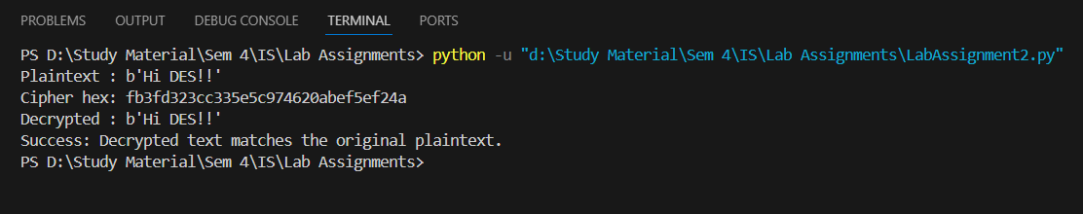
Graded Task 2:
Visualization of MITM Attack Flow: Attacker intercepts plaintext (P) and ciphertext (C) 1. Guess K1 P --[Encrypt with K1]--> Intermediate Value 1 (I1) 2. Guess K2 C --[Decrypt with K2]--> Intermediate Value 2 (I2) 3. If I1 == I2, then K1 and K2 are likely correct. Found the DES key: K = K1 + K2?
Code:
from Crypto.Cipher import DES

def make_key(n: int) -> bytes:
return n.to_bytes(2, "big") + b"\x00" * 6 # small demo key: 2 bytes meaningful

def encrypt_des(plain: bytes, key: bytes) -> bytes:
return DES.new(key, DES.MODE_ECB).encrypt(plain)

def decrypt_des(cipher: bytes, key: bytes) -> bytes:
return DES.new(key, DES.MODE_ECB).decrypt(cipher)

if __name__ == "__main__":
# tiny keyspace 0..255 for super-fast demo
KEYSPACE = 256
P = b'ATTACK!!' # 8 bytes (DES block)
k1_true = 5
k2_true = 200

K1 = make_key(k1_true)
K2 = make_key(k2_true)

# Double DES: C = E_k2(E_k1(P))
mid = encrypt_des(P, K1)
C = encrypt_des(mid, K2)
print("Cipher (hex):", C.hex())

# Phase 1: build table E_k1(P)
table = {}
for k1 in range(KEYSPACE):
val = encrypt_des(P, make_key(k1))
table[val] = k1

# Phase 2: try decrypting C with k2 and look for matches
found = []
for k2 in range(KEYSPACE):
mid2 = decrypt_des(C, make_key(k2))
if mid2 in table:
found.append((table[mid2], k2))

print("Candidates found:", found[:10]) # show up to first 10
print("True pair:", (k1_true, k2_true))

Screenshot:
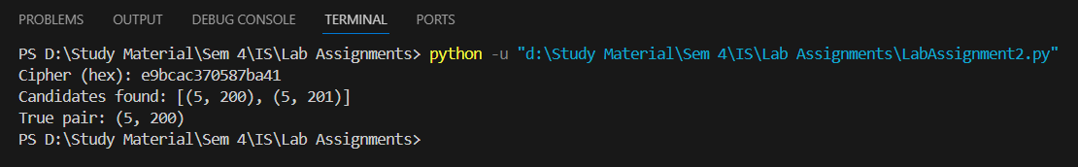

Explaination:
The first script (q1.py) demonstrates how to use PyCryptodome’s DES implementation to encrypt and decrypt byte strings. It includes a fixed-key example (repeatable results) and a random-key example (different every run), uses PKCS#7 padding so messages fit DES’s 8-byte block size, and prints keys and ciphertext in hex for safe storage and display. The second script (q2.py) is an educational Meet-In-The-Middle (MITM) demonstration for double DES: it builds a table of encryptions E_k1(plaintext) for a small keyspace, then for each candidate k2 it computes D_k2(ciphertext) and looks up matches to find possible (k1,k2) pairs. The demo uses a deliberately tiny keyspace (2^16) so it runs quickly for classwork; it prints found candidates, performs a sanity check, and saves a log file. Together these scripts show a practical DES usage example and how naive double-encryption can be attacked with significantly less work than brute-forcing the full combined key.

